|  | Lockout/Tagout Procedure | |
| --- | --- | --- |
| Plant: AOH | Autoinjector Machine | |
| ATS Machine Unit 1 | Line 2 |
| Lockout/Tagout Application Process | | |
| **1.** Prepare for shutdown **2**. Notify all affected personnel **3.** Properly shut down the machine **4.** Isolate all energy sources by switching E1 to “OFF” position. Isolate compressed air by closing A1 valve to off position. **5.** Apply lockout devices to all identified locations **6.** Dissipate any residual energy 7**.** Verify complete de-energization of all sources by pressing start button on the machine. | | |

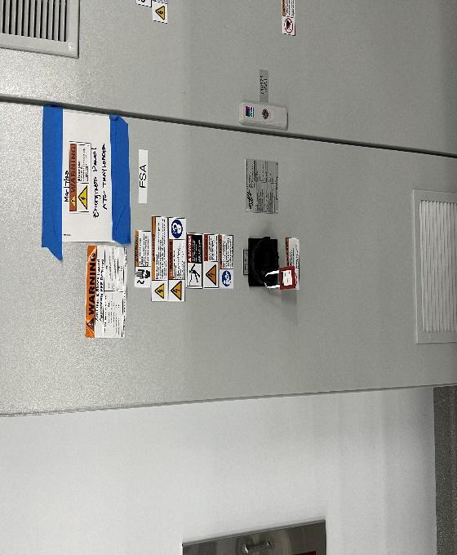 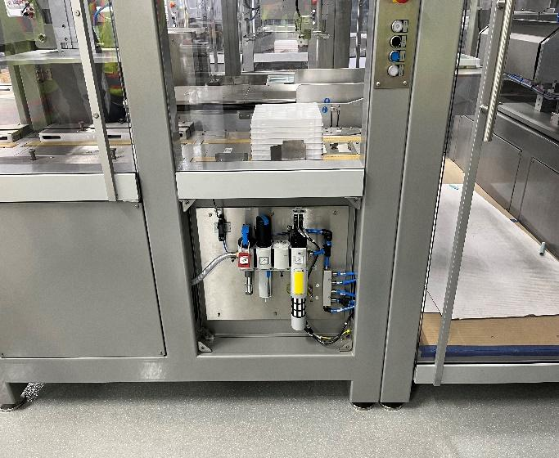 

| Energy Source | Magnitude | Location | Method | Symbol |
| --- | --- | --- | --- | --- |
| Electrical | 480v | Main electrical panel on the side of the machine | Turn off breaker handle | E1 |
| Compressed Air | 100psi | Main air-line next to machine | Turn off air valve | A1 |
| Lockout/Tagout Removal Process |
| **1**.. Only the person who installed the lockout/tagout device is allowed to remove it  **2**. Ensure all tools and equipment have been removed **3**. Confirm all employees are accounted for **4**. Verify that all controls are in a neutral state **5**. Remove lockout/tagout devices  **6**. Reenergize machine **7**. Test equipment for correct operation and resume normal operations |

**Alternative Protection Measures**

Some servicing operations performed during normal production operations are excepted from coverage under the Lockout/Tagout standard. This exception is referred to as the minor servicing exception.

**Minor Servicing Exceptions must meet the following criteria:**

1. **The activity must be conducted during normal production operations.**
2. **The activity must be routine, repetitive, and integral**
   1. ***Routine* - The activity must be a regular course of procedure and be in accordance with established practices.**
   2. ***Repetitive* - The activity must be regularly repeated as part of the production process.**
   3. ***Integral*: The activity must be essential to the production process.**
3. **There must be alternative protection measures to provide effective protection from hazardous energy.**

**Procedure Explanations:**

This procedure applies to all Amgen personnel as well as any outside contractors that are either Primary Authorize Person (PAP), Authorized and Reviewer to perform Lockout/Tagout or affected by this Lockout/Tagout procedure.

A Lockout/Tagout is required for maintenance and servicing activities such as:

Constructing, installing, adjusting, inspecting, modifying, and maintaining and/or servicing machines or equipment

Repairing and/or maintaining equipment during normal production operations require a Lockout/Tagout if:

An employee is required to remove or bypass a guard or other safety device

An employee is required to place any part of his or her body into an area on a machine or piece of equipment where work is performed (point of operation) or where an associated danger zone exists during a machine operating cycle The purpose of this procedure is to prevent equipment from accidently being energized by an unknowing employee. As a result of this procedure an energy isolating device must be installed on each of the labeled disconnect locations.

Only employees that have been formally trained and authorized to perform Lockout/Tagout procedures should be servicing a machine. All affected employees shall be notified anytime there is work to be done in their area.

There are detailed steps under the “Lockout/Tagout Application Process” section that identify each step in the lockout process in numerical order. All steps should be followed in numerical order without skipping any step.

Each picture will show the energy isolating location on the machine. Labeling methods include either E (Electrical), M (Mechanical), W (Water), A (Air) and followed by a red arrow pointing to the energy isolating device or measure. The identified energy source will allow employees servicing or performing maintenance operations to know the steps and visually see where locks should be applied.

A key is provided to define the energy source type, the location of the isolating mechanism, the method to effectively use the isolating mechanism, and the symbol that will identify the visual location.

Under the “Lockout/Tagout Removal Process” the key steps of removing a lock or tag are listed in numerical order. Each step should be completed in its entirety before moving to the next.

**Testing or Positioning**

**Lockout/Tagout still must be used when troubleshooting or testing equipment. When Lockout/Tagout devices must temporarily be removed, the following steps must be followed:**

1. **Clear machine of tools, equipment, etc.**
2. **Ensure all employees are clear of the danger zone**
3. **Remove Lockout/Tagout devices**
4. **Energize and proceed with testing (Must wear any required PPE including but not limited to Arc Flash wear, safety goggles, specialized gloves, etc.)**

**De-energize all systems and reapply energy control measures**